**Fr. Conceicao Rodrigues College of Engineering**

**Bandra**

**Computer Department**

**SEM-V**



**Web Technology Project**

**Group Members:**

Pratik Chowdhury (8322)

Elvis Dsouza (8333)

Vedant Sahai (8364)

**Guide:** Mr. Mahendra Mehra

**TABLE OF CONTENTS**

1. Introduction -----------------------------------------------------------------------------------3
2. Purpose-----------------------------------------------------------------------------------------[3](https://docs.google.com/document/d/1yiQD5JIT2LfrJvNP56V6GUplDq_htukmBVKHTXuqb8Q/edit#heading=h.3rdcrjn)
3. Technology Stack-----------------------------------------------------------------------------[3](https://docs.google.com/document/d/1yiQD5JIT2LfrJvNP56V6GUplDq_htukmBVKHTXuqb8Q/edit#heading=h.3rdcrjn)

4.   Process

4.1 Faculty Side---------------------------------------------------------------------------------4

4.2 Admin Side----------------------------------------------------------------------------------5

5. ER Diagram--------------------------------------------------------------------------------------6

6.  Functional Requirements

6.1 Registration----------------------------------------------------------------------------------7

6.2 Teacher Login-------------------------------------------------------------------------------7

6.3 Admin Login--------------------------------------------------------------------------------8

7.  Non-functional Requirements

7.1 Safety and Security-------------------------------------------------------------------------8

7.2 Software Quality Attributes---------------------------------------------------------------9

7. Future Aspect------------------------------------------------------------------------------------9

9. Use Case-----------------------------------------------------------------------------------------10

10. System Outlook--------------------------------------------------------------------------------11

11. Conclusion-------------------------------------------------------------------------------------14

13. References--------------------------------------------------------------------------------------14

**INTRODUCTION**

In this ever-growing age of the technology the faculties teaching in the engineering college must be constantly updated in terms of technology, skill, practicality, and applications. To get updated the faculties attend various conferences, workshops, seminars etc. As these faculties constantly update themselves it becomes extremely hard for the institute to keep a track of their educational activities. Hence through this web application of ours we the teacher could not only keep a track of his/her educational activities but at the same time the institute would also be able to keep a track on the educational activities of its teachers without breaching the privacy of the faculty.

**PURPOSE**

The purpose of this document is to describe the requirements for the Teacher’s Portal System. It includes the information about the teachers. In this system the teacher will be able to keep a track of their educational activities which they will be able to display it in their respective college websites and at the same time the college will be able to generate reports for the accreditation purposes.

**TECHNOLOGY STACK**

**Front End:**

* HTML5
* CSS3
* Bootstrap
* jQuery
* Embedded JavaScript

**Server End:**

* NodeJS
* Express
* Sequelize
* Archiver.js
* bcrypt
* PostgreSQL as the database

**PROCESS**

**Faculty Side---**

* To create an account, the faculty first must contact the administrator to create a username and password for that faculty.
* Once the account is created by the administrator, the faculty logins into the account with the provided login credential and enters the home page of the teacher’s portal system which initially would be empty.
* Once logged in successfully the faculty then has to navigate him/her with help of the navigation bar and fill in his personal, educational details along with industry and teaching experiences which he/she has incurred in the past years.
* Once this update is done, it will be reflected in the profile which the faculty can anytime change as per the convenience.
* The faculty can also upload documents about various research paper published, seminars and workshops attended or conducted etc. with its proper details and documents in the form of docx, pdf, excel, photo etc.
* Again, the faculty will be able to edit/delete/view this information in the profile page where with the help navigation bar and buttons the faculty could navigate through the portal.
* At the end if the faculty needs to change the password provided by the administrator, the faculty can also achieve that by going into the change password setting in the portal.

**Administrator Side---**

* The administrator has a predefined password provided by the system developer which the administrator can also change it as per his/her convenience.
* The administrator will be able to see the list of users in his home page where he/she can keep a track on the account created so far in the portal .Also the admin will be able to delete the unnecessary accounts in the portal where the faculty have left the institute but still their account exists in the system.
* Administrator oversees the generation of faculty account just by inserting the username for that faculty and a randomly generated value is sent by the system itself as the password for that username.
* One of the most important aspects of the administrator is to generate report or do an advanced search on the basis if the mentioned parameters for easy identification and generating reports which can be used by the college to show the achievements/proof of the faculties to the concerned authorities.

**ER DIAGRAM**

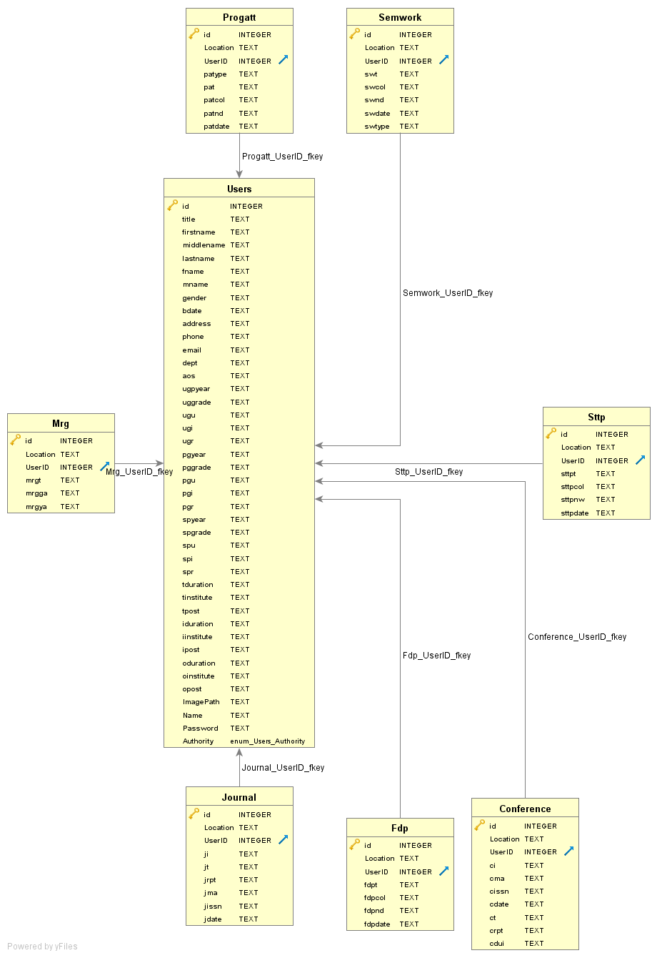

**FUNCTIONAL REQUIREMENT**

**Registration**

* System will allow the admin to create a username corresponding faculty.
* The system will give each passenger a **PASSWORD.** And add it to the teachers record.
* During the creation of the teachers account a teacher ID will also be associated with the teacher which can be used for further filter purposes and identification.

**Teacher Login**

* **See Profile:** Over here the teacher will be able to see his/her profile with all the details which the teachers have entered initially. The faculty will also be able to see the documents uploaded with their metadata and can update, download, or view whenever he/she wants it to
* **Update Profile:** This is two in one page where the faculty will be able to enter as well as update his personal and educational details along with the experiences which he/she has incurred over the period of years be it in the industry filed or the teaching field.
* **Upload Document:** There are 6 major categories in which the faculty can upload the document int the portal according to its type.

The 6 types are as follows:

1. Faculty Development Program (FDP)
2. Short Term Training Programs (STTP)
3. Research & Grants and Consultancy
4. Seminars and Workshops Attended
5. Conferences
6. Programs Attended

* **Change Password:** The initially supplied password by the admin is a system generated password which can be changes by the faculty when he/she logins into his/her account

**Admin Login**

* **Users List:** Through this page the admin will be able to keep an track o the number of accounts created so far in the system and will also be able to delete any inactive accounts in case the faculty leaves the institute.
* **Create User:** It is nothing but the registration of the faculty for an account for that faculty to be created in that institute when he/she joins the institute.
* **Generate Report:** This section of this system is purely restricted to the administrator through which the admin will be able to generate report based on the following parameters-

1. Year
2. Faculty Name
3. Department
4. International or National Level
5. Category of the Document
6. Sponsorship

* **Change Password:** The predefined password of the admin is a programmer programmed password which can be changed by the admin when he/she as per his/her convenience from the admin account.

**NON-FUNCTIONAL REQUIREMENTS**

**Safety and Security Requirements**

* **Login ID:** Any user who uses the system shall have a Login ID and Password.
* **Modification:** Any modification (insert, drop, and update) for the Database can be done by the teacher as well as the admin in a synchronized manner.
* **Administrators**' **Rights**: Administrators shall be able to view and change only the accounts present in the system. The administrator will not be able to drop/modify any data in any of the existing accounts.
* **Encryption and Hashing:** Security is the prime and the utmost importance of this system and hence we have used high level of encryption and hashing of files as well as data so that data stored doesn’t get leaked or hacked at the same time it is not accessible by all as well thus maintaining a hierarchy.

**Software Quality Attributes**

**Maintainability---**

* **Back Up:** The system shall supply the capability to back-up the Data.
* **Reliability:** Availability The system shall be available all the time.
* **Network Connection**: They should be connected to internet 24 X 7. And the Server Must is on all time.

**FUTURE ASPECT**

* Add an advanced search choice for the administrator. At the same time even give a choice to download this filtered search in the form of excel/pdf.
* Evaluate the system in the production environment to find out more glitches and improve its efficiency and performance.
* Dockerise the whole web application for easy installing of the system tools and other technologies required for its smooth functioning.

**USE CASE**

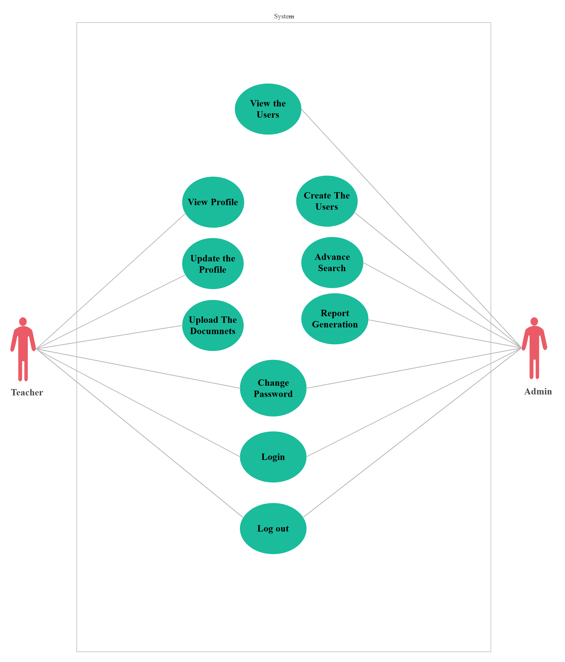

**SYSTEM OUTLOOK**

* Faculty profile page

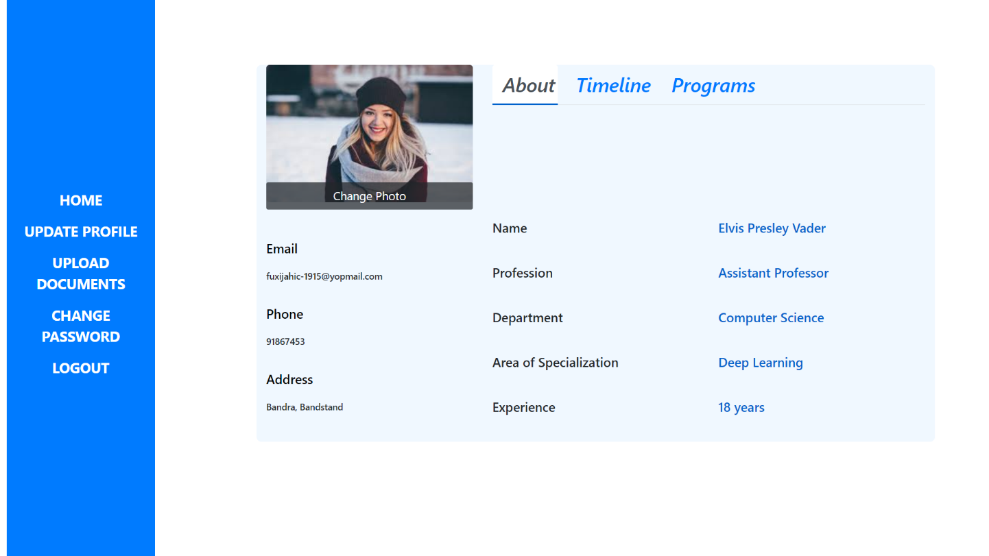

* Faculty update page

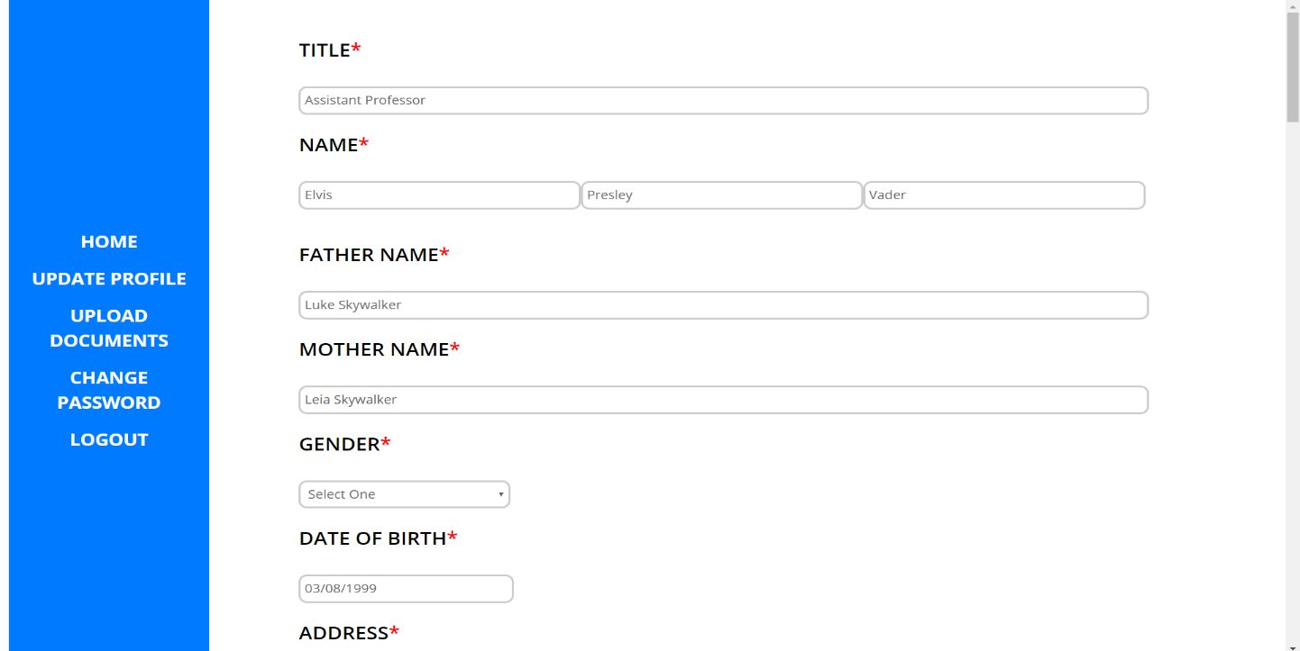

* Faculty upload document page

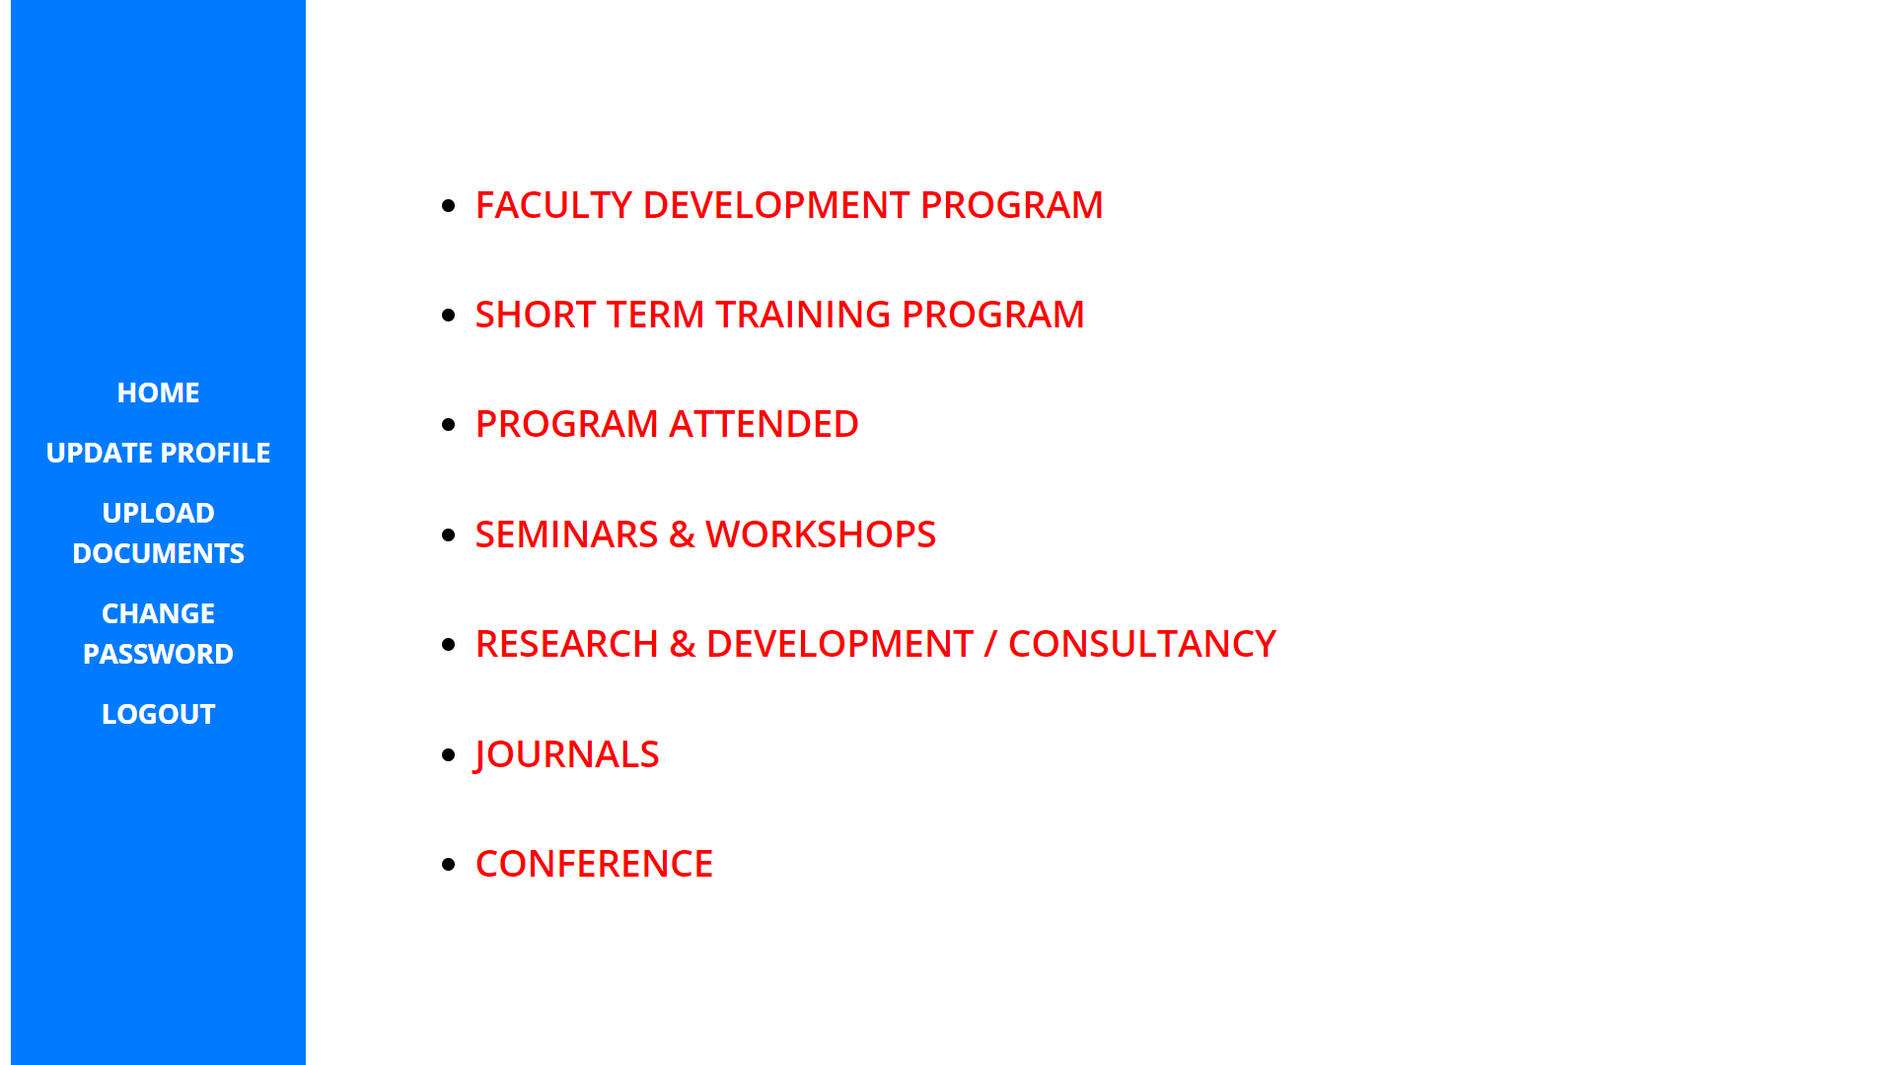

* Administrator home page

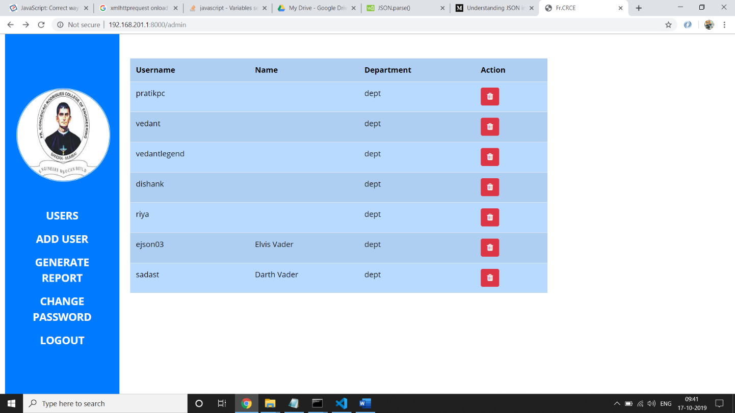

* Administrator Report Generation page

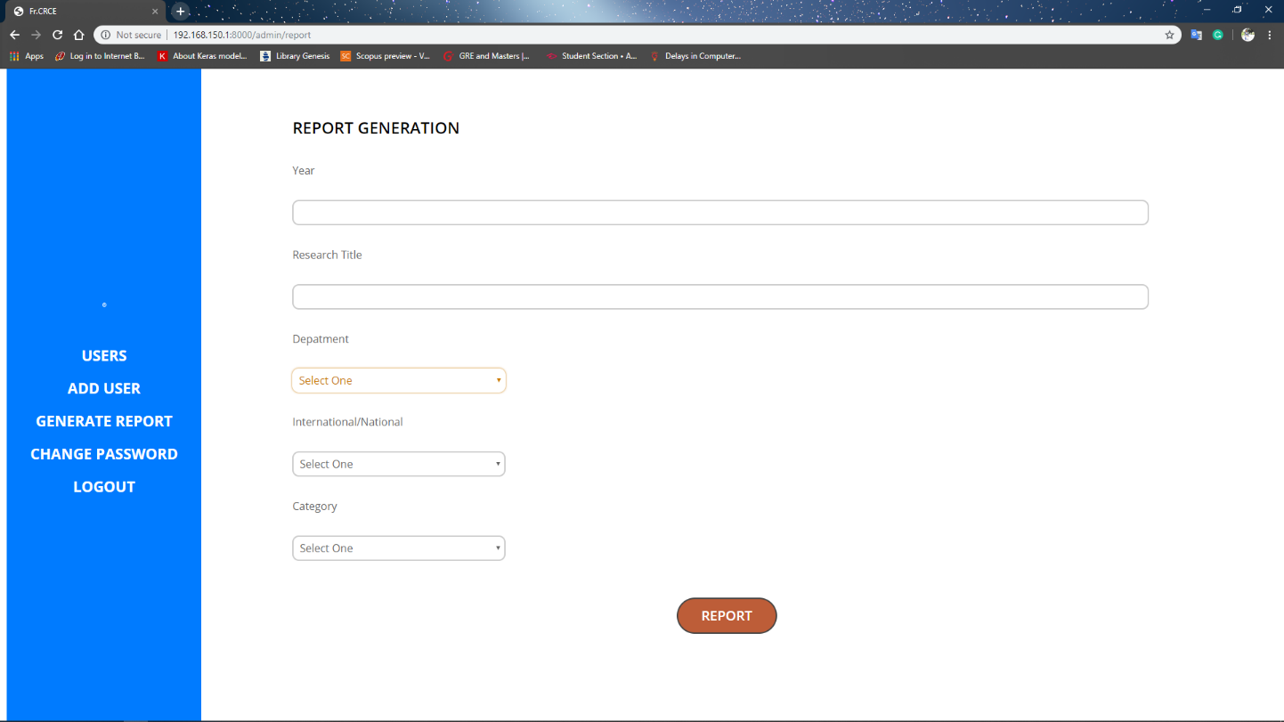

**CONCLUSION**

To conclude, on the completion of this project the faculty as well as the institute administrator will be able to manage the faculties documents leading to successful report generation ,while the teacher can keep a track on their development activates thereby enabling them to update themselves in an efficient way along keeping an record for the same.

**REFERENCES**

1. <https://app.creately.com/diagram/yCMCAVfAcis/edit>
2. <https://www.postgresql.org/>
3. <https://nodejs.org/en/docs/>
4. <https://api.jquery.com/>
5. <https://www.w3schools.com/>
6. <https://www.tutorialspoint.com/ajax/what_is_ajax.htm>
7. <https://www.npmjs.com/package/bcrypt-nodejs>
8. <https://sequelize.org/>
9. <https://expressjs.com/>
10. https://www.npmjs.com/package/sequelize-typescript